Web Development

* HTML is about content
* CSS about formatting and styling through the DOM; cascading si riferisce alla gerarchia del DOM, se formatti il body, tutto il body è così
* Javascript is about the page doing things, i.e. send data from the page to the server

HTML

Textbooks:

* [Learn to Code HTML & CSS](https://learn.shayhowe.com/html-css/)
* [W3 Schools tutorial](https://www.w3schools.com/html/)

Code of this course:

* [HTML5 Course Code](https://intro-webdesign.com/v3/html5.html#code)

Validation tools:

* [W3C html validator](https://validator.w3.org/#validate_by_input)
* [Wave accessibility evaluation](https://wave.webaim.org/)

Other:

* [The true story of the Internet](https://www.youtube.com/watch?v=Gh6N1uPjGno)
* [Interview with Joseph Hardin, creator of Mosaic](https://www.youtube.com/watch?v=-c8iWUh3Sv4&app=desktop)
* [HTML basic examples from W3C](https://www.w3schools.com/html/html_basic.asp)

HTML uses tags to distinguish between content (what the user should see) and the instructions for displaying them (make this a list, make this a link to a different page, show this picture, etc.)

It was originally intended only to share scientific documents with hyperlinks.

When Mosaic (first GUI to the internet) arrived, strong debate between scientists and others whether images, video, audio and styling should be part of it. Also, browsers tried to introduce proprietary tags, which was against the spirit of HTML. Fortunately proprietary tags ended, and since 2005, the styling went to CSS while HTML stayed focused on content.

HTML5 follows some principles:

* New features should be based on HTML, CSS< the DOM and Javascript only. Nothing else.
* Reduce the need for external plugins (i.e. Flash)
* Markup to replace very common scripts, i.e. if most sites use some js functionality, make it a tag
* Device independent (phone, tablet, etc.)

An URL that we use to make requests is made of 3 components:

* Protocol (i.e. https)
* Domain
* (optional): a document, a file, originally the html file, but today many files: i.e. the html file, pictures, CSS, JS scripts, etc.

This is an important concept: an HTML page is a that calls other files, it’s like a hub, a set of instructions to compose a final result made of many pieces.

In terms of editors, recommended is VS code (save as html, type ! and hot tab, and see why it’s better than Sublime!)

Organization:

* Html folder for the each project
* Sub folders: img, css, js

DOM

An HTML page follows a hierarchical structure, called the DOM. The DOM is not something written explicitly, but a software can navigate the tags of an html page based on the concept of the DOM.

DOM è una struttura ad albero della pagina, dove ogni nodo=element è un tag, e dove puoi cercalo per nome (id), per tipo(p, div) o per (tipo e) posizione, i.e. il secondo p in questo div.

HTML is the top of the hierarchy

Below we have HEAD and BODY

Below the HEAD we have TITLE, metadata, etc.

Below we have other tags, i.e. in BODY we have H1, P, and others.

If you write well formatted code that follows the concept of the DOM, tabbing tags that are below a certain tag, you and others will read it more easily.

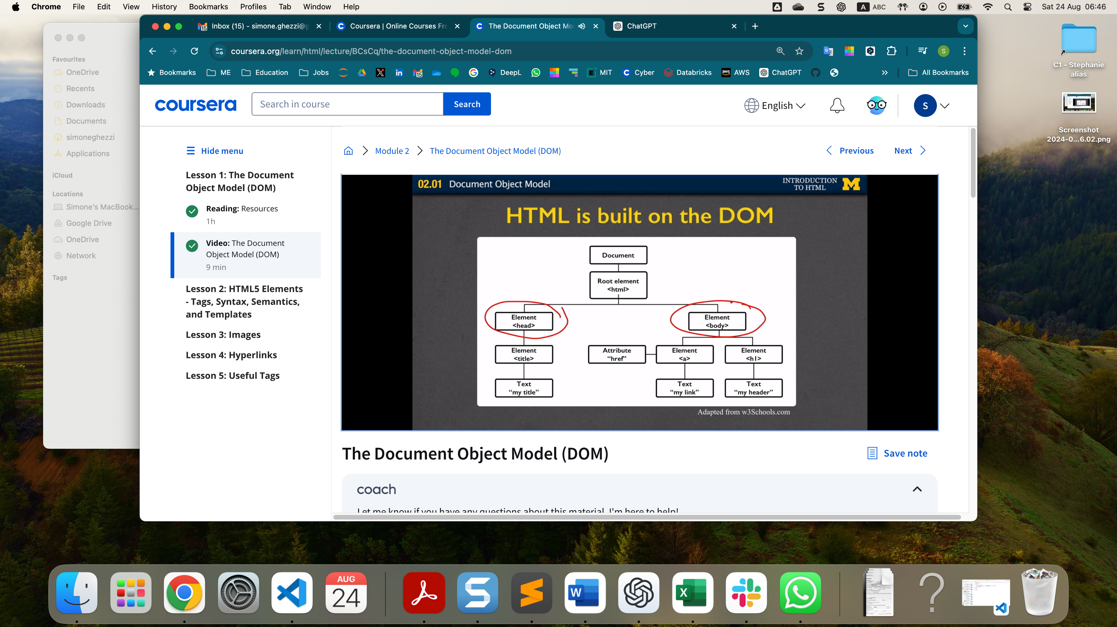

TAGS

Most important: h1, h2, p, br, hr, pre, a, img, lists: ul, ol, li

You can’t learn all tags, the list is too long. You can use cheat sheets or google searches:

* [The ultimate HTML5 cheatsheet](https://www.wpkube.com/html5-cheat-sheet/)
* [HTML Cheat Sheet](https://htmlcheatsheet.com/)
* [WebAIM: HTML Semantics and Accessibility Cheat Sheet](https://webaim.org/resources/htmlcheatsheet/)

Tags usually need to be opened and closed, i.e.:

<h1>title</h1>

Others are self-closing:

<img src=”img.jpg”>

ATTRIBUTES

Some tags have atttibutes, like the img above or the link, below:

<a href=[www.site.com](http://www.site.com) link>

vengono sempre in forma key=value pairs, i.e. href = 'www.ciao.com', src = 'img.jpg'

class is not a tag but a tag attribute, simile a function options, i.e. img src "img.jpg" class = "thumbnail"

un altro attribute comune è id, un unique identifier per un elemento della pagina, facilita il trovarlo quando fai i.e. javascript e/o data analysis

Some tags are block and some are inline: block tags take the whole line, i.e. <h1>, <p>, <div>. Others are inline and can take a smaller part of the line.

In the past, <div> was very popular, but since it’s too generic, with HTML5 it has been replaced by more specific tags called [semantic tags](https://www.w3schools.com/html/html5_semantic_elements.asp), that indicate which kind of element you are opening and closing.

Regarding images, the best way to work would be to save the image exactly in the size that you want displayed. Also, you want to give the image a very good name, that explains what the image is about.

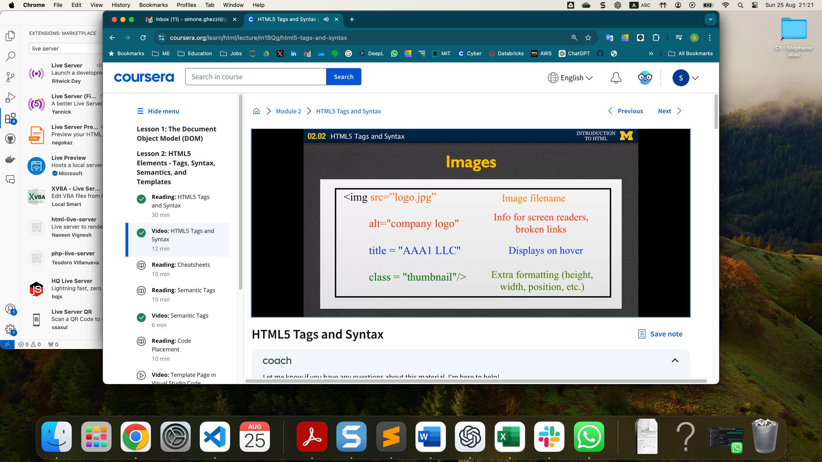

When you hit space, html will not repeat the space nor the line break. For this, you need to use special entities:

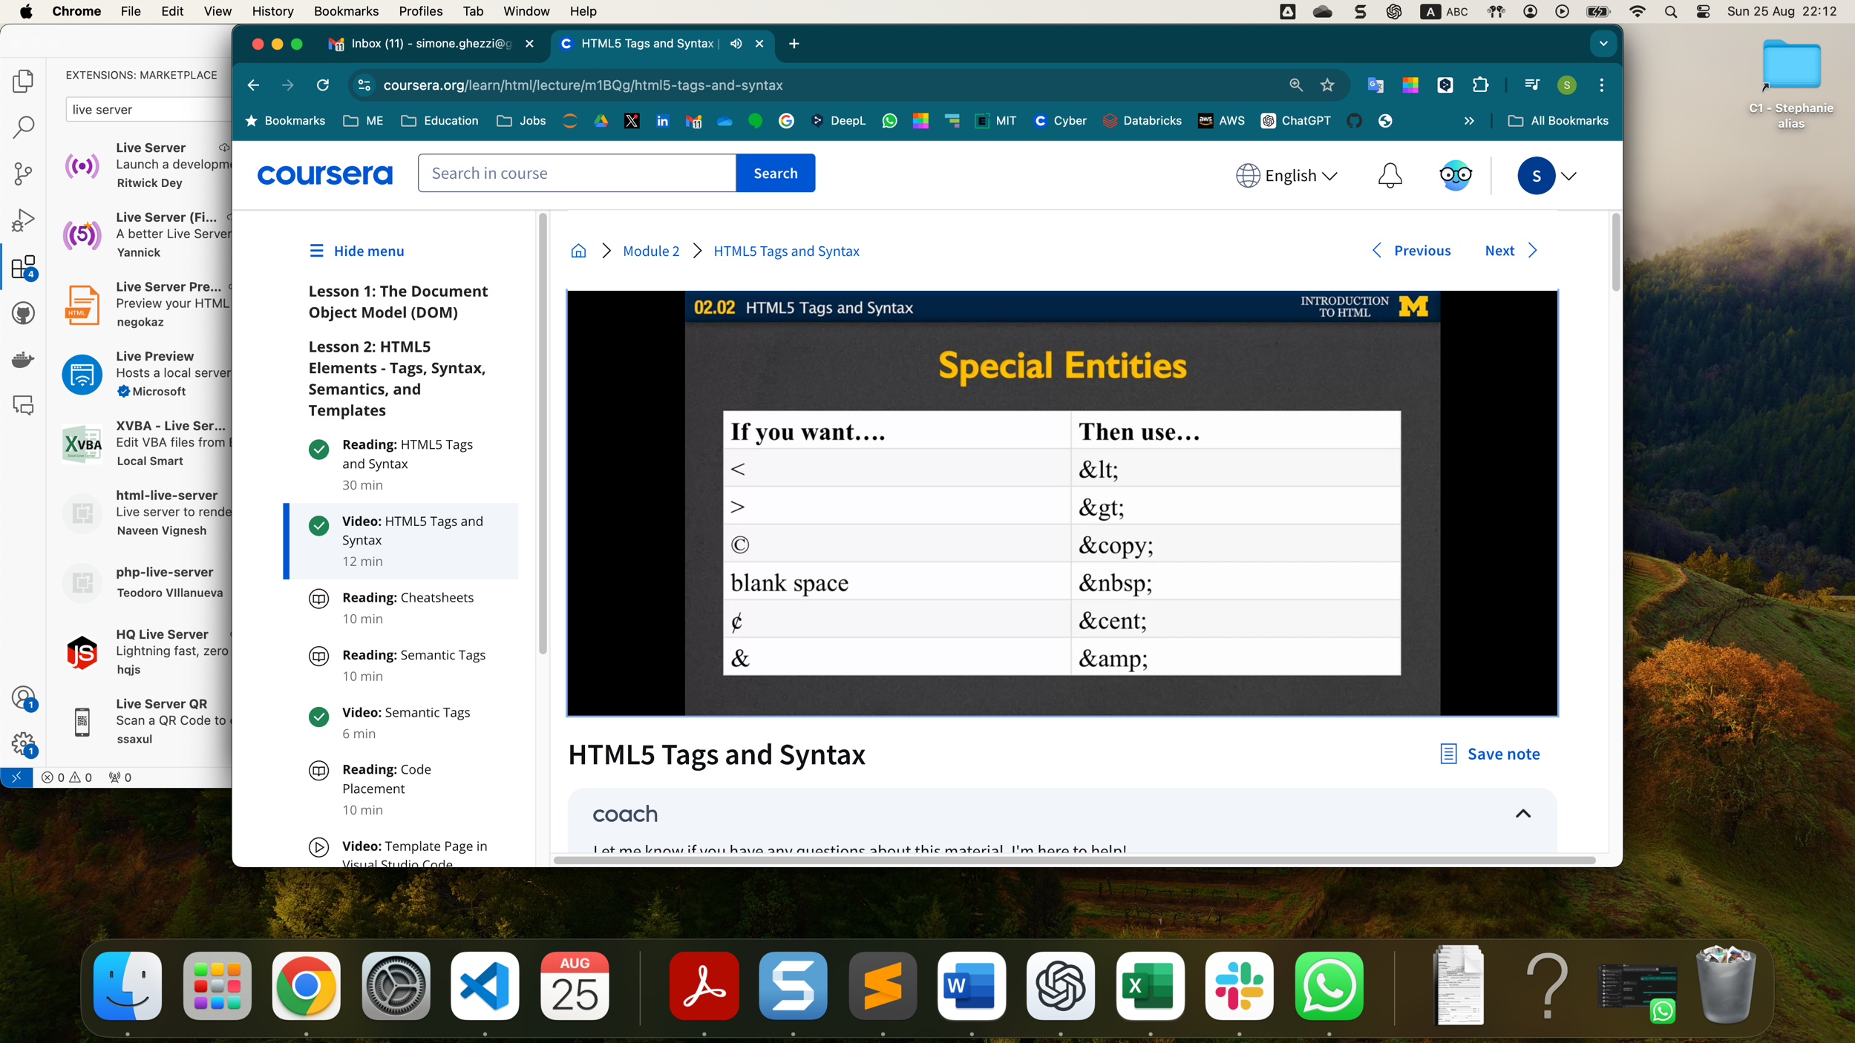

SEMANTIC TAGS

They replace <div>, which used to be i.e. like <div class=”header”>

Most used semantic tags:

<header>, i.e. for title, navigation bar

<nav>, i.e. for a navigation bar, in this case the nav bar is embedded into the <header> tag.

<main>

<article>, i.e. for blog posts

<section>

<footer>

There are many others that are worth checking out.

IMAGES and ICONS

* Every image must be downloaded by the browser, so not size and location of the image impacts speed, so makes sense to have all images available on your server (i.e. not on some other site) and resize it to the dimension that it will be displayed
* If you want better accessibility on different screen sizes, you can only set the width to the % of the device window, i.e. 50%; this will tell the browser to take 50% of whatever window size they have.
* Alternatively, to size an image, use “style” instead of width and height, so that CSS does not overwrite it:
  + Not <img src="html5.gif" alt="HTML5 Icon" width="128" height="128">
  + But <img src="html5.gif" alt="HTML5 Icon" style="width:128px;height:128px;">
* The text should describe the image if the image contains information
* The text should explain where the link goes if the image is inside an <a> element
* Use alt="" if the image is only for decoration
* For icons, the equivalent of alt is called aria-label
* Icons are called by the tag <i>: see link here below
* To use icons, you can use one of these [services](https://www.w3schools.com/icons/) proposed by W3school

ANCHORS (=links)

* Absolute, i.e. someone else’s page
* Relative, i.e. a file inside your server
* Internal,

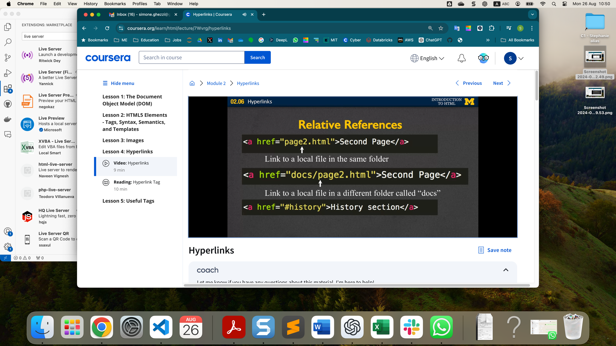

USEFUL TAGS

* Use HTML5 semantic tags instead of generic tags like <p> or <div>
* <hr> is very useful
* <address> allows browsers to recognize addresses
* <code>